

Office of Information Technology

Serving Public Diplomacy
Version 1.0 DRAFT
March 19, 2004
⬥ Bureau of International Information Programs
⬥ Bureau of Educational & Cultural Affairs
⬥ U.S. Department of State

Exchange Visitor Database (EVDB) Test Plan

Table of Contents
Section 1 Introduction 1
1.1 Purpose of this Document 1
1.2 Applicability 1
1.3 Scope 1
1.4 Process 1
Section 2 Features to be Tested 1
2.1 IEMS Functionality 1
2.2 Workflow Diagram 1
2.3 Data Exchange Test Procedures 2
2.3.1 Phase 1 2
2.3.2 Phase 2 2
2.3.3 Phase 3 3
2.3.4 Phase 4 3
2.3.5 Phase 5 3
2.3.6 Phase 6 3
2.3.7 Phase 7 3
2.3.8 Phase 8 3
2.3.9 Phase 9 3
2.3.10 Phase 10 3
Section 3 Features not to be Tested 3
Section 4 Approach 4
4.1 IEMS Application Testing: 4
4.2 IEMS Data Exchange Testing: 4
Section 5 Environmental Needs 5
5.1 Setup and Preparations 5
5.2 Hardware Requirements 5
5.3 Testing Location 5
Section 6 Test Deliverables 5
Section 7 Schedule 5
Section 8 Responsibilities 6
Section 9 Staffing and Training 6
9.1 Staffing 6
9.2 Training 6
Section 10 Risks and Contingencies 6
Section 11 Approvals 7
APPENDIX A A-1

Introduction

Purpose of this Document
The Test Plan prescribes the scope, approach, resources, and schedule of testing activities. It identifies the items to be tested, the features to be tested, the testing tasks to be performed, the personnel responsible for each task, and the risks associated with the plan. It is used to set goals and expectations of the testing effort.

Applicability
This process applies to all civilian and Department of State ECA-IIP/IT/AP & ECA-IIP/IT/NUS EVDB development, test, and technical team members.

Scope
The scope of this document is to present the two-fold process for testing the EVDB application. First, the successful transmission of data from and between the Post EVDB, Post and NPA Monitor, Department of State EVDB, and IEMS information sources in a timely and accurate manner. By doing so, we will have a complete circle of information between Posts, DOS and Program Agencies. Second, testing the EVDB application functionality outside of the exchange of data.

Process
This document will outline the exchange data testing process in a phased approach. Each phase will be documented as an individual success or failure based on the various test incident reports created. Each test case will encompass a variety of situations where data anomalies will be demonstrated in order to document the pass or fail criteria. The EVDB functionality will be tested using the test specification chart in Appendix A.

Features to be Tested

EVDB Functionality
Test entire functionality of the EVDB application including but not limited to the specific new and/or improved items in EVDB (see Appendix A Test Specifications). Test entire functionality of the EVDB data exchange using Post EVDB, EVDB, Monitor, Website, and the IEMS application.

Workflow Diagram
The diagram below, demonstrates the dataflow that will be tested during the test phases.

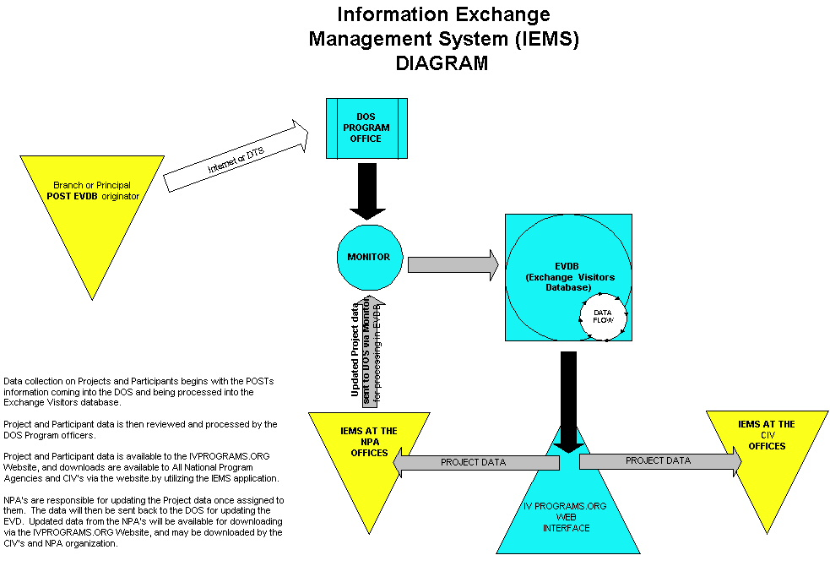
PHASE 1 & 6
PHASE 2
PHASE 3 & 7
PHASE 5
PHASE 4 & 8
PHASE 9

Data Exchange Test Procedures

Phase 1
Data is submitted from the Post EVDB
- Obtain a Post file submission.

Phase 2
Data is submitted to the EVDB
- Post file is sent to the ECA Monitor.

Phase 3
Data is validated in the EVDB
- Approve the data was received into the EVDB.
- Update data to approve the project and participant nominations for submission to the web.

Phase 4
Validate data appears on the IV Program website.

Phase 5
Data is validated, modified, and exported in the IEMS applications
- Approve the data was received in the IEMS applications.
- Update data in IEMS NPA Project module.
- From IEMS NPA, export project file to the NPA Monitor.

Phase 5
Data is submitted from the Post EVDB
- Obtain a modified Post file submission.
- Post file is sent to the ECA Monitor.

Phase 6
Data is approved and updated in the EVDB
- Approve the modified Post and NPA data was updated and/or deleted in the EVDB.
- Update data in the EVDB in the Change Table feature.

Phase 7
Data is validated in the Website
- Approve the modified data was received into the IV Programs web site.

Phase 8
Data is imported into the IEMS applications
- Import projects from the Stored Proc Runner into IEMS NPA and CIV.
- Approved modified data was updated and/or deleted.

Features not to be Tested
This system test is limited to the data exchange and the EVDB functionality and not the functionality of other applications used during the data exchange. Testing will not target non-data exchange functionality of the Post EVDB and IEMS applications and Website.

Approach

EVDB Application Testing:
Testers need to test the application including the following high-level functionality.
- Manage existing projects.
- Start with the Project Management window.
- You will also use the Project Editor, and various dialogs.
- Review changed data from Posts or NPAs.
- Start with the Review NPA/Post Changes tab page of the Project Management window.
- You will also use the Review Changes dialog.
- Assign one or more participants to an existing project.
- Start with the Project Management window, open a Project Editor, then click on the Participants tab.
- Request a program agency for a project.
- Open the project in a Project Editor, and then open a Create Message dialog.
- Assign a DOS program officer to a project.
- Create a new project.
- Record the project's itinerary.
- Start with the Project Management window, open a Project Editor, then click on the Itinerary tab.
- Record the appointments for a Voluntary Visitors project.
- Start with the Project Management window, open a Project Editor, then click on the Itinerary tab.
- Read or send messages.
- Enter data about a new or previously listed organization.
- Enter data about a person.
- Add a city to the list of cities.
- Record or check funding allocation data.
- Print reports, messages, or screen captures of window.
- Sending SEVIS data to INS, and printing DS-2019 forms.
- Open and read the online Help Menu

EVDB Data Exchange Testing:
Testers need to test the data exchange portion of the application as shown is Section 3. This test must incorporate the EVDB application as well as Post EVDB, IEMS, and the ECA and NPA Monitors.

Item Pass/Fail Criteria

Pass Criteria
Using the Test Specification, the line item meets the minimum requirements for pass.

Fail Criteria
Using the Test Specification, the line item does not meet the minimum requirements for passing.

Suspension Criteria and Resumption Requirements
There are no suspension criteria or resumption requirements. The application will not be released until all parties have signed off based on the test specification requirements.

Environmental Needs

Setup and Preparations
Setup | Staff Assigned
EVDB Installation on all test machines | NUS
Scheduling training room | Niki Deanda
Ensuring test environment is ready | NUS, Niki Deanda

Hardware Requirements
Requirement | Staff Assigned
EVDB | NUS
Post EVDB | NUS
IEMS NPA | Art Powell
Monitors | Darrell Garner
Website | Eric Shaffer
NT Machine | Niki Deanda
2000 Machine | Niki Deanda
98 Machine | Niki Deanda

Testing Location
System testing will be conducted at SA-44 in the 6th floor training room. The EVDB Design Team members who are responsible for “signing” off on this release will conduct Acceptance Testing. Acceptance Testing will be located at their individual locations within SA-44.

Test Deliverables
The following documents may be included for each testing phase:
- Test plan (System test and Acceptance test are including in one Test Plan approach)
- Test specifications
- Test incident reports

Schedule

System Test
System testing will begin on Date. System test will take place in 2 cycles, the first cycle will test the database functionality and the second cycle will test the data flow in and out of EVDB from Post and NPA IEMS. System test will take 14 hours or 2-full working days. Results are due in by COB each day, and should be submitted directly to Niki Deanda. System testing must be completed no later than Date.

Acceptance Test
Acceptance test will begin on Date. Acceptance test will take place in 2 cycles, the first cycle will test the database functionality and the second cycle will test the data flow in and out of EVDB from Post and NPA IEMS. Acceptance test will take 40 hours or 5 full working days. Results are due in by COB each day and should be submitted directly to Niki Deanda. Acceptance testing must be completed no later than Date.

Responsibilities
Groups responsible for managing, designing, preparing, executing, witnessing, checking, and resolving.
Responsibility | Group
Managing | Project Management
Designing | Project Management and Business Analyst
Preparing | Business Analyst
Executing | Project Management, Business Analyst, Developer, Super User
Witnessing | Test Manager
Checking | Test Manager
Resolving | Developer
Approving | Test Manager

Staffing and Training

Staffing

The following staff will participate in System Test:
Developer: Lee DeUnger, Jayant Midha
Business Analyst: Niki Deanda
Testing Manager: James Cyphers

The following staff will participate in Acceptance Test:
Super Users: Members of the EVDB Design Team

Training
Niki Deanda will brief all super-users the functionality to be tested during Acceptance Test.

Risks and Contingencies
Risk A: The items identified in the Environmental Needs section will not be accomplished in the given system test time period due to DOS regulation constraints on software development.
Contingency A: NUS will be kept in communication if any system malfunctions occur or need improving during testing.

Approvals
Niki Deanda, Project Manager, Jayant Midha and Lee DeUnger, Developers, will sign off on all Test Incident Reports. James Cyphers, Test Manager, will approve final Test.

